

**24ADI001-** **ARTIFICIAL INTELLIGENCE AND AUTOMATION**

**--------------------------------------------------**

**2025-2026**

**LAB RECORD**

**DEPARTMENT OF ARTIFICIAL INTELLIGENCE AND DATA SCIENCE**

**INDEX**

|  |  |  |  |  |
| --- | --- | --- | --- | --- |
| **Expt. No** | **Title of the Experiment** | **Page No** | **Total Marks** | **Faculty Signature** |
|  | Intelligent Agent Simulation |  |  |  |
|  | Propositional Logic and Knowledge-Based Agent |  |  |  |
|  | First Order Logic and Inference (Chaining and Resolution) |  |  |  |
|  | Search Algorithms (BFS, DFS, A, AO)** |  |  |  |
|  | Game Development (Tic-Tac-Toe or Chess) |  |  |  |
|  | Backtracking and Constraint Satisfaction (Sudoku, N-Queens) |  |  |  |
|  | Bayesian Networks and Hidden Markov Models |  |  |  |
|  | Markov Decision Processes and Game Theory |  |  |  |
|  | Robotic Process Automation (UiPath) |  |  |  |

**Average marks Faculty Signature**

|  |  |
| --- | --- |
| **EXPT NO:1** | **Intelligent Agent Simulation** |
| **DATE: 23.09.2025** |

**PRE-LAB QUESTIONS (PROVIDE BRIEF ANSWERS TO THE FOLLOWING QUESTIONS)**

1. What is a **knowledge-based agent**?

A knowledge-based agent uses a knowledge base and inference mechanisms to make decisions. It stores facts about the world, applies reasoning, and chooses actions intelligently based on logical deductions.

1. Convert the statement "If it rains, the ground will be wet" into propositional logic.

Let **R** = "It rains"

**W** = "The ground will be wet."

The propositional logic representation is:  
**R → W**

1. What is the difference between **syntax** and **semantics** in logic?

Syntax refers to the formal structure and symbols of a logical language. Semantics concerns the meaning, interpretation, and truth of expressions. Syntax defines form; semantics defines understanding and truth.

**IN-LAB EXERCISE:**

**OBJECTIVE:**

To simulate a **Knowledge-Based Agent** using **Propositional Logic** to solve a real-world scenario (e.g., a smart home security system).

**PROCEDURE:**

**1. Preparation:**

* Install Python (or use an online IDE like Replit).
* Install the logic library (!pip install logic for propositional logic operations).
* Understand basic logical operators (AND, OR, NOT, IMPLIES).

**2. Scenario:**

* **Problem Statement:** A smart home security system uses sensors (Door, Window, Motion) to trigger an alarm.
  + Rules:
    - If Door is open **AND** Motion is detected → Alarm sounds.
    - If Window is open → Alarm sounds.
    - If Motion is detected **AND** no one is at home (Home=False) → Alarm sounds.

**3. Implementation Steps:**

1. Define propositional symbols:
   * D = Door open
   * W = Window open
   * M = Motion detected
   * H = Someone is home
   * A = Alarm sounds
2. Encode rules in propositional logic:
   * Rule 1: (D ∧ M) → A
   * Rule 2: W → A
   * Rule 3: (M ∧ ¬H) → A
3. Implement in Python using truth tables or logical inference.
4. Test with different sensor inputs (e.g., D=True, M=True, H=False → Alarm should trigger).

**CODE:**

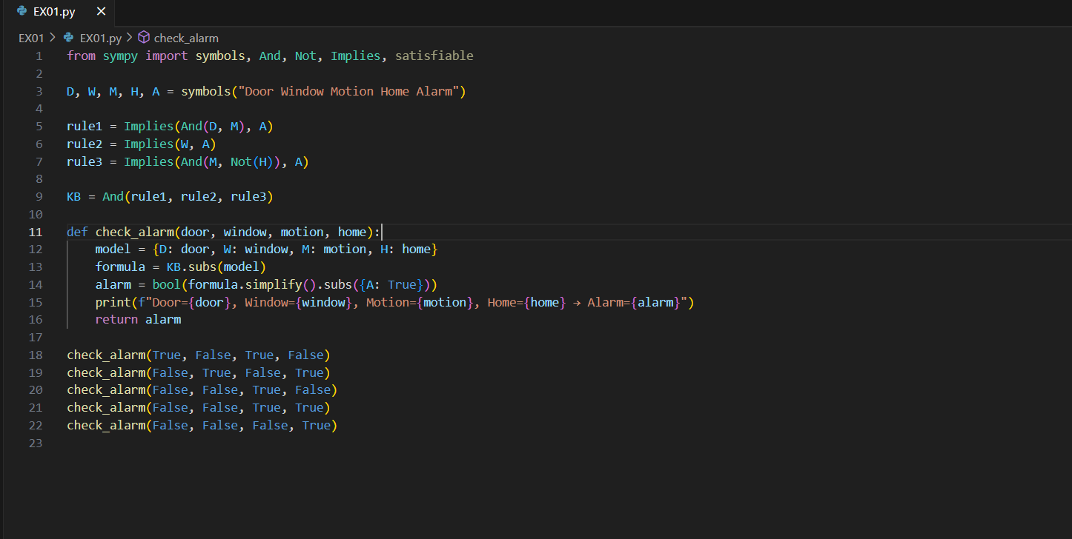

**OUTPUT:**

**POST-LAB QUESTIONS (PROVIDE BRIEF ANSWERS TO THE FOLLOWING QUESTIONS)**

1. How would you modify the rules if a new sensor "Glass Break (G)" is added?

To add the Glass Break sensor (G), update the rules so the alarm triggers

Window (W), Heat (H), or Glass Break (G)

is true: **(W ∨ H ∨ G) → Alarm**.

1. What happens if W=True and H=True? Does the alarm trigger?

If **W = True** and **H = True**, then at least one sensor condition is satisfied.

According to the rule, the alarm will certainly trigger, regardless of other sensor states.

1. Explain **resolution** in propositional logic.

Resolution in propositional logic is an inference rule eliminating complementary literals across clauses. By systematically combining clauses, contradictions emerge or conclusions are proven. It’s fundamental in automated theorem proving and logic.

**ASSESSMENT**

|  |  |  |
| --- | --- | --- |
| **Description** | **Max Marks** | **Marks Awarded** |
| Pre Lab Exercise | **5** |  |
| In Lab Exercise | **10** |  |
| Post Lab Exercise | **5** |  |
| Viva | **10** |  |
| **Total** | **30** |  |
| **Faculty Signature** | |  |